stormwater drainage system
MAINTENANCE PLAN

[INSERT SUBDIVISION NAME]
HOME OWNERS ASSOCIATION

[INSERT DATE]

[INSERT SUBDIVISION NAME] HOMEOWNERS ASSOCIATION
FOLEY, BALDWIN COUNTY, ALABAMA

Provided by

CITY OF FOLEY
23030 WOLF BAY DRIVE
FOLEY, ALABAMA 36535
(251)-923-4267

TABLE OF CONTENTS

SECTION PAGE
NO. TITLE NO.
1.0 INTRODUCTION AND GENERAL INFORMATION 1
1.1 Purpose of This Plan 1
1.2 General Site Description 1
2.0 ORGANIZATIONAL RESPONSIBILITIES (BEST MANAGEMENT PRACTICES TEAM) 2
3.0 GENERAL BEST MANAGEMENT PRACTICES 3
3.1 Good Housekeeping 3
3.2 Preventive Maintenance 3
4.0 SPECIFIC BEST MANAGEMENT PRACTICES 4
4.1 Grass Swale(s) and Lined or Hard-Armored Swale(s) 4
4.2 Detention Pond(s) & Retention Pond(s) 4
4.3 Curb Inlets 4
4.4 Bioretention Area(s) 4
4.5 Retention Pond(s) with Steep-Sloped Banks 5
5.0 PLAN REVIEW AND UPDATE PROCEDURES 6

LIST OF EXAMPLE IMAGES

Images 1,2,3,4 Erosion

LIST OF FIGURES

Figure 1 Site Diagram

LIST OF APPENDICES

Appendix A Related Documentation
- Quarterly Inspection Checklist

INTRODUCTION AND GENERAL INFORMATION

Purpose of This Plan

This plan has been prepared to ensure the structural stormwater controls located within the [INSERT SUBDIVISION NAME] Subdivision are properly maintained to operate as designed. Best Management Practices (BMPs) for the structural stormwater controls in this plan are based on the City of Foley Subdivision Regulations, City of Foley Manual for Design and Construction, Ordinance: 17-2029-0RD, and the Alabama Handbook for Erosion Control, Sediment Control and Stormwater Management on Construction and Urban Areas Volume 1 and Volume 2.

General Site Description

The [INSERT SUBDIVISION NAME] subdivision is a residential development. Structural stormwater controls addressed in this plan include:

- Grass swale(s) (vegetated)
- Lined swale(s)
- Detention and Retention pond(s)
- Curb inlets (City will make repairs within the Right-Of-Way )
- Bioretention Area(s)

ORGANIZATIONAL RESPONSIBILITIES (BEST MANAGEMENT PRACTICES TEAM)

The Homeowners Association (HOA) will be responsible for maintaining the structural stormwater controls on an as-needed basis but at a minimum of semi-annually. A quarterly inspection checklist has been included in Appendix A of this plan to aid the HOA in determining when maintenance may be required. In addition, the covenant in place for the HOA should be referred to for pertinent details concerning organizational responsibilities.

GENERAL BEST MANAGEMENT PRACTICES

Good Housekeeping

Generally, good housekeeping involves sound practice in the operation and maintenance of the stormwater controls. Good housekeeping best management practices include:

- Regular grounds maintenance (mowing, weed clearing, etc.) and routine clean-up of trash and debris,
- Routine visual inspection of structural stormwater controls and required repairs, if needed,
- Ensure outlet pipes are free from obstruction.

At a minimum, all structural stormwater controls should be maintained semi-annually.

Preventive Maintenance

Preventive Maintenance includes quarterly inspections of the structural stormwater controls. Structural stormwater controls should also be inspected after any rainfall event of four inches or more in a contiguous 24-hour period. This is a method of reviewing the effectiveness of the controls and identifies possible conditions that may interfere with the designed operation. Conditions that may interfere with the controls can include structures, obstructions, erosion, debris, vegetation, etc. that are impeding the flow of stormwater.

Preventive Maintenance Best Management Practices include:

- Periodic inspections of stormwater controls,
- Removing obstructions, debris, vegetation, sediment accumulation, etc. as needed
- Stabilizing eroded areas

A quarterly inspection checklist can be found in Appendix A.

SPECIFIC BEST MANAGEMENT PRACTICES

Grass Swale(s) and Lined or Hard-Armored Swale(s)

The following are Best Management practices for the grass swale(s):

- Inspect the channel at regular intervals and following storm events for blockage, ponding, sediment, erosion.
- Remove any obstructions, blockage or sediment buildups that may impede the flow of stormwater.
- Make repairs to eroded areas.
- Check outlet for damage and repair if needed.
- Mow and fertilize vegetation for grass swales.

Detention Pond(s) & Retention Pond(s)

The following are Best Management Practices for the detention pond(s):

- Inspect the ponds at regular intervals and following storm events for debris and erosion. Check for erosion on the banks and at the inlet and outlet pipes/structures. Backfill areas of erosion with new soil, or with rock, stone, or gravel, if necessary.
- Remove any obstructions, trash, and debris from ponds and the inlet/outlet structures.
- Mow vegetation regularly. Volunteer (non-planted) trees/shrubs should be removed from the banks and from inside the ponds.
- Check for “islands” forming in ponds, or other indications that fines are building up in the structure, and that there are changes in depth.

Curb Inlets

Curb inlets are located throughout the subdivision. The following are Best Management Practices for the curb inlets:

- Inspect the curb inlets at regular intervals and following storm events for any obstructions. Advise the City Public Works Department if problems are noted.
- Keep curb inlets free of obstructions.
- Note erosion under and around inlets and advise the City.

Bioretention Area(s)

The following are Best Management Practices for the bioretention area(s):

- Remove any trash, sediment, and debris from the bioretention area(s).
- Remove weeds/unwarranted vegetation from the bioretention area(s).
- Vegetation should be landscaped/maintained on an as-needed basis.
- Replace dead plant material, as needed.
- Repair any damaged or eroded areas.
- Repair overflow structure, if present.
- Unclog underdrain if not draining correctly.

Retention Pond(s) with Steep-Sloped Banks

The following are Best Management Practices for the retention pond(s) with steep banks:

- Remove any trash, sediment, and debris from the sloped area(s).
- Vegetation should be landscaped/maintained on an as-needed basis.
- Mow vegetation regularly. Volunteer (non-planted) trees/shrubs should be removed from the banks and from inside the ponds.
- Check for “islands” forming in ponds, or other indications that fines are building up in the structure, and that there are changes in depth.
- Exposed areas of soil should be vegetated appropriately and with permanent vegetation.
- Replace any damaged or eroded areas of soil, such as washed out trenches or areas without grass. (See Example Images)
- Replace dead or dying plants and vegetative cover, as needed.
- If areas of erosion persist, consider installing rock, stone, or gravel, and consider consulting a professional for advice.

PLAN REVIEW AND UPDATE PROCEDURES

This plan may be reviewed periodically to ensure that it is up to-date. The plan may be modified whenever there is a change in design, construction, or maintenance, which has a significant effect on the operation of the structural stormwater controls addressed in this plan. Every five years the owner of the subdivision storm water detention facilities shall review the effectiveness of the structural stormwater controls. If any deficiency exists, an engineering firm should be consulted to develop a list of correcting actions and a schedule for completing these actions.

EXAMPLE IMAGES

IMAGE 1: EROSION

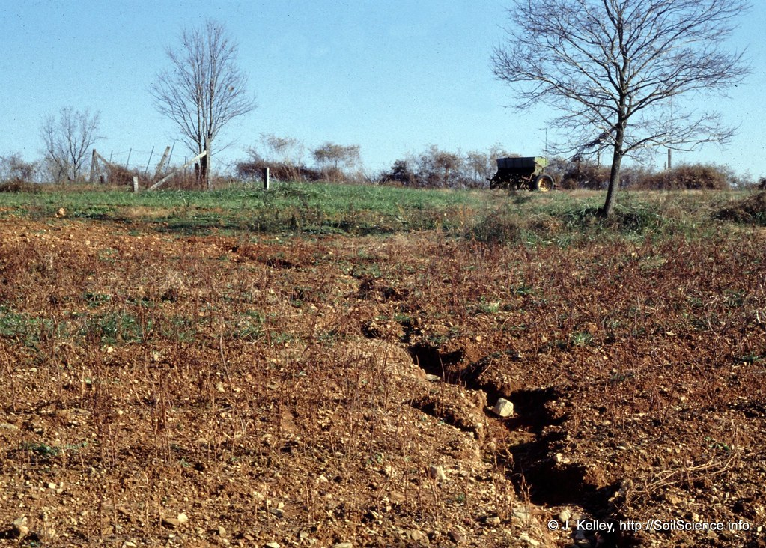

IMAGE 2: EROSION
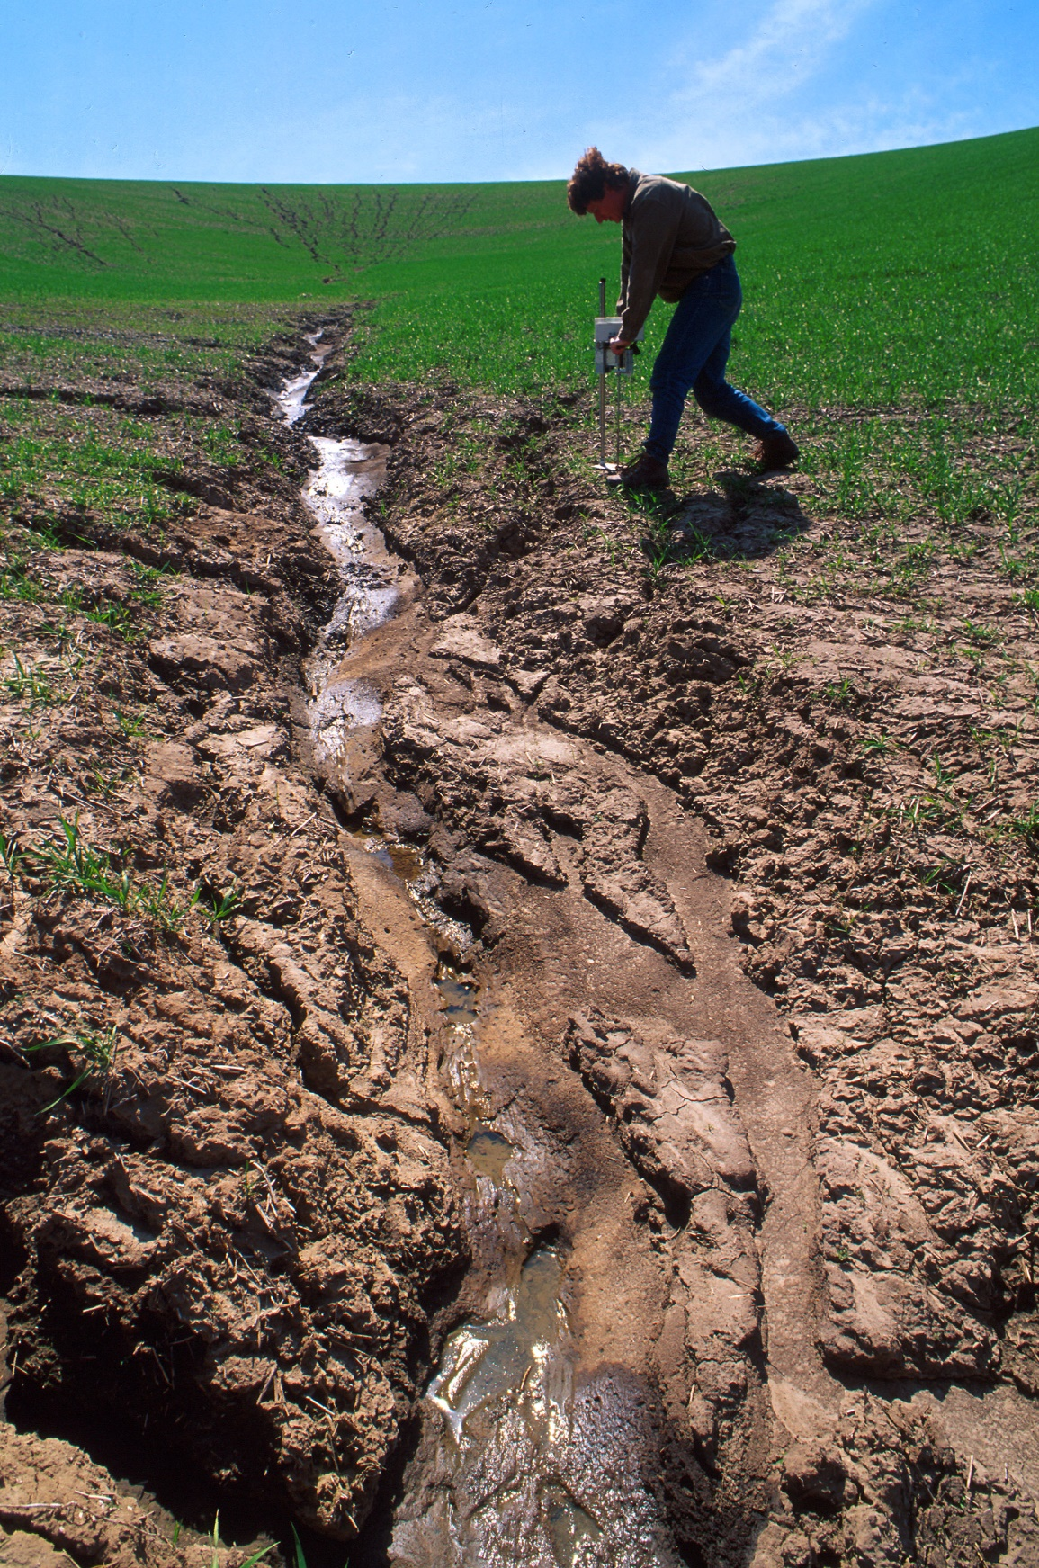

IMAGE 3: EROSION

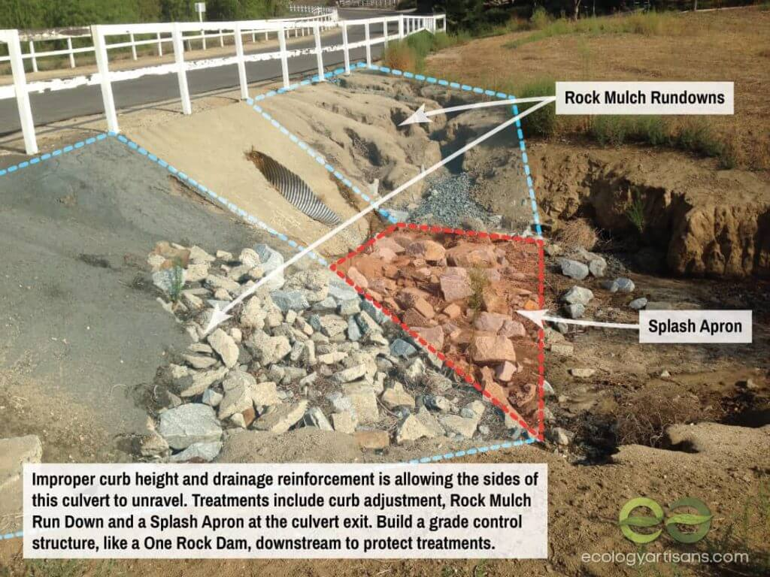

IMAGE 4: EROSION

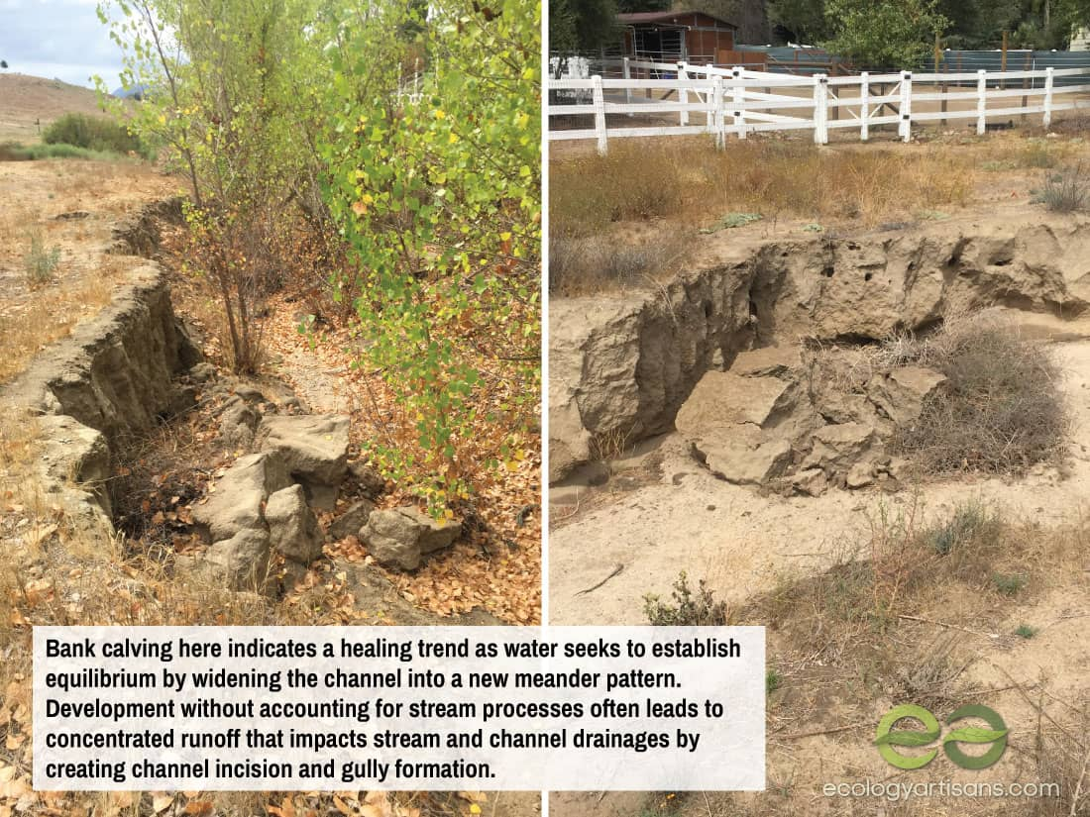

FIGURES

[Insert Site Diagram]

APPENDIX A

Related Documentation

QUARTERLY INSPECTION CHECKLIST

Inspection point | yes | no | Description (Give location)

Grass Swale(s)/Hard Lined Swale(s)
Blockage within swale
Ponding within swale
Sediment buildup
Erosion within swale
Need mowing
Detention Pond(s)
Debris in pond
Bank erosion
Erosion at inlet or outlet of pond
Need mowing
Curb Inlets
Ponding at inlet
Free from obstruction
Erosion around inlet
Bioretention Area(s)
Debris in area
Erosion in area
Sediment build up
Landscaping Needed
Erosion of overflow structure
Draining correctly
Retention Pond(s) with Sloped Banks
Sediment Buildup
Debris along slopes
Vegetation in need of maintenance
Exposed areas of soil along bank(s)
Erosion in area
Dead vegetation in area

END OF DOCUMENT

(This page was intentionally left blank)

