As a builder/homeowner, how do I meet the International Residential Code’s thermal and ignition barrier requirements when using spray polyurethane foam in an attic and/or crawl space?

Thermal Barrier: All polyurethane spray foams require a code-approved thermal barrier— ordinarily a layer of ½” drywall—between the foam and the living space (IRC R316.4). The thermal barrier is designed to make it more difficult for a fire inside the living space to gain access to the fresh source of fuel in the spray foam, leaving the home’s occupants with more time to escape. Luckily, most ceiling assemblies in residential houses qualify as a code-approved thermal barrier — separating between the foam and the living space.

Ignition Barrier. Builders/ Homeowners have three options for attic and crawlspace use:

(1) they can combine any spray foam with a prescriptive barrier;
- use an approved combination of foam and intumescent coating, or
- choose a foam that has been tested and approved by the ICC-ES test without any protective barrier.

Ignition barriers are required in foam-insulated attics, crawlspaces, and other areas with limited access that can’t be used as living space. They offer a lower order of protection, and are intended simply to prevent a possible flame source from making direct contact with the foam (Vara).
- Prescriptive Barrier. The IRC lists six prescriptive ignition-barrier materials (IRC R316.5.3):
- 1 ½” mineral fiber insulation;
- ¼ wood structural panels, such as plywood;
- 3/8” particleboard;
- ¼” hardboard;
- 3/8” gypsum board;
- and corrosion-resistant steel with a base-metal thickness of 0.016 inch or more.

Apply any of these materials over the foam in areas where an ignition barrier is required, and you’ve met code.

- Intumescent Coatings. Spray foam can also be protected with an intumescent coating, which is applied like paint and bubbles up when exposed to heat, forming a flame- resistant barrier layer. Unlike prescriptive ignition barriers, though, such coatings must

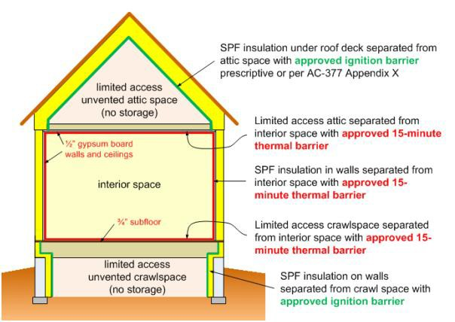

earn code approval on a case-by-case basis by passing a burn test—ACC 377, appendix X, also known as the modified NFPA 286 test--administered by the ICC-ES. Virtually all spray-foam manufacturers now offer products that qualify for attic or crawlspace use when combined with an appropriate coating material.

- Foams Tested without Ignition Barriers. Several open-cell foams on the market have been tested and approved by the ICC-ES for residential use without an added ignition barrier. But as that product category continues to grow, it’s worth considering what ignition barriers are designed to do, and how the new non-barrier foams fit into the picture (Vara).

Application Examples:

Unvented Attic and Crawl Space

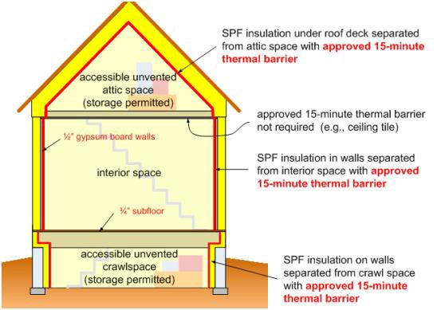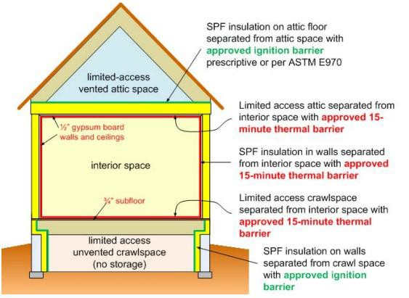

Unvented Attic and Crawl Space – with Storage

Vented Attic and Unvented Crawl Space

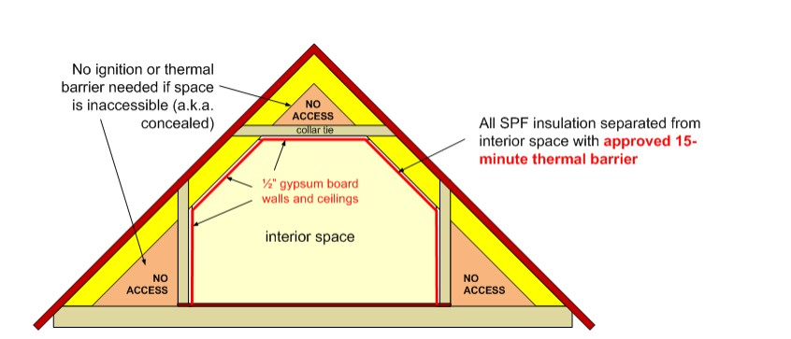

Finished Room Over Garage

References

Vara, J. (2012). Making Sense of Spray Foam and Ignition Barriers. The Journal of Light
Construction. Retrieved September 23, 2015, from http://www.jlconline.com/how-
to/insulation/making-sense-of-spray-foam-and-ignition-barriers_o

International Residential Code for One- and Two-Family Dwellings. (2012). Country Club Hills, IL: International Code Council.

